# Math Quiz

Create a simple web application that will display basic mathematical questions to the user and allow them to submit answers.

Questions are to be provided by the backend whenever the user clicks a “get new question” button and on the initial page load. The questions will always be made up of two numeric values and an operation. Operations can be addition, multiplication, subtraction and division

E.g. (2x2, 2+4, 10-3)"

A user can enter their answer and click a “submit answer” button to send their answer to the backend for processing.

The backend should respond with whether or not the user’s submission is correct or not and the front end should handle this response appropriately.

Your application must be made up of a frontend and backend that are separate. Your frontend should communicate with your backend via an api.

The User Interface can be laid out however you want but they must include the following:

* The current question’s id value
* The first number value
* The operation
* The second number value
* An input field for the user to enter an answer
* A submit button to send the user’s answer to the server
* A button to get a new question from the server (this should automatically update the page)

A possible layout for the frontend is as follows:

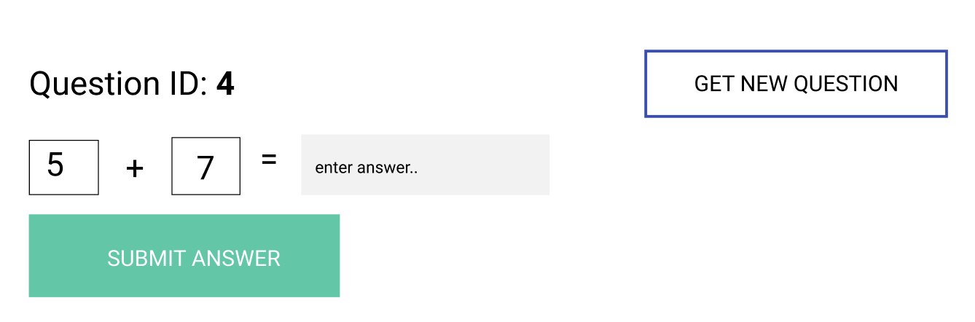

In a real application, a database would typically be used to store the questions however for the purpose of this assessment you can simply hardcode a few questions on the backend. You can structure these as you see fit.

You may use any language you like, along with any framework or library you deem suitable.

Upon completion you must submit your code(both front end and backend) to a public GitHub repository, along with any instructions on how to install and run your application.

{Class of Questions, this will be hardcoded later}

type

TQuestion = class

ID: integer

A: double

B: double

Operator: char {+ - / *}

End

//implementation

{Retrieve a question from the server}

Procedure Client.NewQuestionBtnClick

With Server.GetNewQuestion do

QuestionID := ID;

ValueA := A

ValueB := B

Operation := Operator

End;

End

{Get a random question}

Function Server.GetNewQuestion: TQuestion

Result := TQuestionList[random(1..10)] //Hard-coded list of 10 TQuestion Objects

End;

{Submit user response and question back to server, await answer evalution}

Procedure Client.SubmitAnswer

If Server.PostAnswer(TQuestion, response) then

Correct

Sleep(500);

NewQuestionBtnClick

Else

TryAgain

End;

{Compare user response to evaluated answer}

Function Server.PostAnswer(TQuestion, response): Boolean;

op := StringIndexOf(TQuestion.operator, [+, -, /, *])

Case op of:

1: answer := TQuestion.a + TQuestion.b

2: answer := TQuestion.a - TQuestion.b

3: answer := TQuestion.a / TQuestion.b

4: answer := TQuestion.a * TQuestion.b

End

If answer = response then

Result := true

Else

Result := false

End;

Procedure Client.Onload

NewQuestionBtnClick

End